View Parishioners Status for Data Cleanup

- Login to https://siouxfalls.parishsoftfamilysuite.com/ with your username and password.
- Once logged in click on the Family Directory tab.
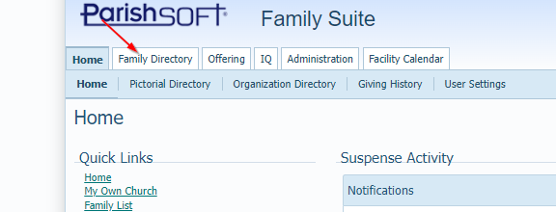

- Once you see a list of parishioners in the grid you can click on the filter icon to view only your registered parishioners. Select the “Registered” option in the Membership dropdown list and select “Active” in the Family Group dropdown list. Once both are selected click the blue Apply button.
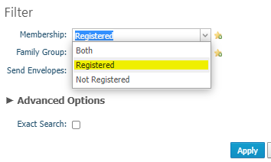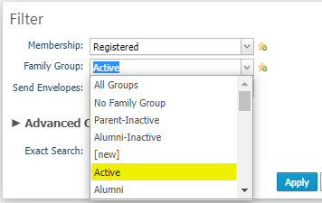

- This should take you back to the main screen with your list of Parishioners.
  - This button will clear the filters that we had set in step 3 and will show all parishioners assigned to your parish including registered and all family groups.
  - This button will allow you to export a list into excel format if you feel more comfortable reviewing the list in this format. You will still have to make the changes individually within ParishSOFT though.
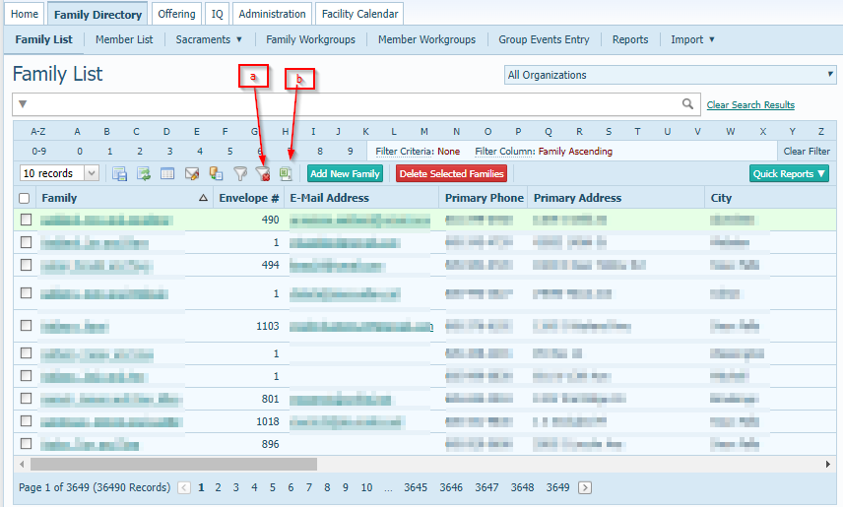

- *You may also want to check some other membership and Family Group combinations. One example would be select Membership=Registered and Family Group= Deceased. We do not want Deceased members to be registered so we would want to uncheck that and also double check that the Send Mail is not checked.
