Generate Contribution Reports
- Login into Parish Soft and click the offering tab.

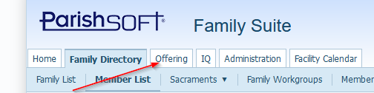

- Once the page loads click on the “Go to Offering” link

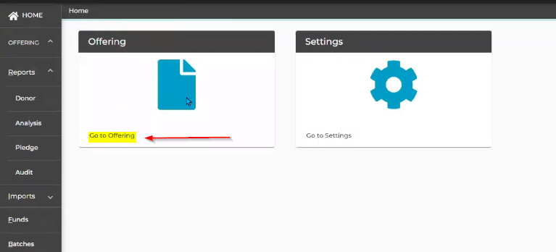

- On the Reports area click on Donor.

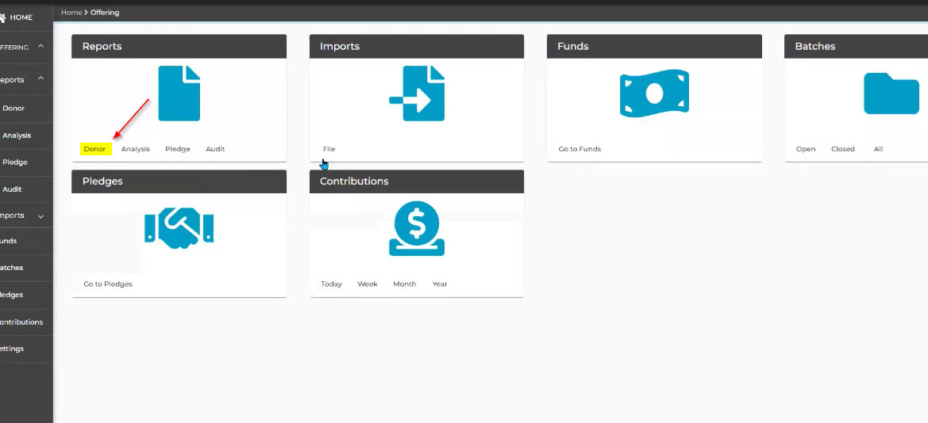

- Select “Contribution Detail Statement Report” from the select a donor report dropdown.

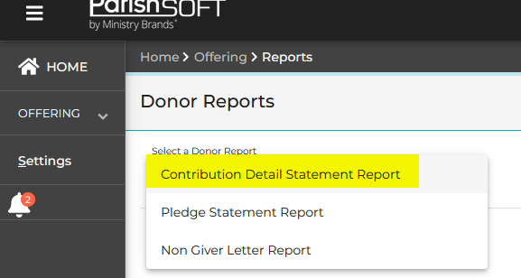

- Click on the icon in the upper right hand corner and select filters.
  - Under the Include contribution types select all the items in this list unless you have some reason to exclude one for year end statements.
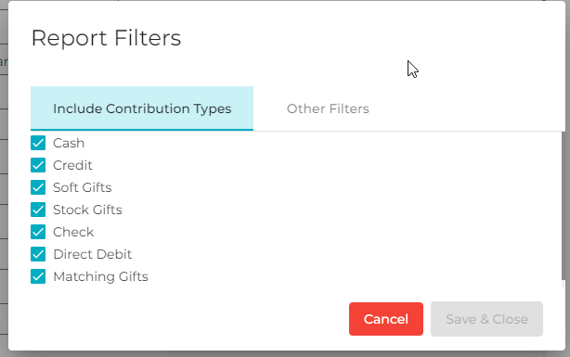
  - Under the Other filters set the options you would like. The main one to note is the include non-tax-deductible contributions should be unchecked if this is End of Year statements. *UNLESS, you want to show gifts that were given directly to the Diocese through online giving and were for the benefit of your parish, then you would want to include non tax deductible contributions

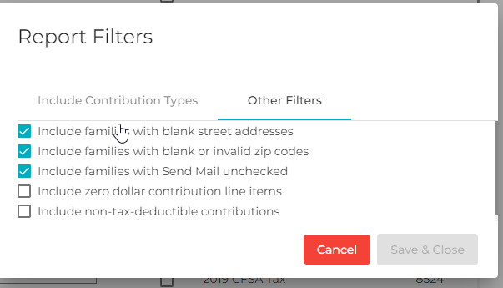

- Click on the icon in the upper right hand corner and select contents.
  - Select how you want the name to show up in the Mailing address. Selecting “Family Formal Mailing Name” from the dropdown is best for this process.
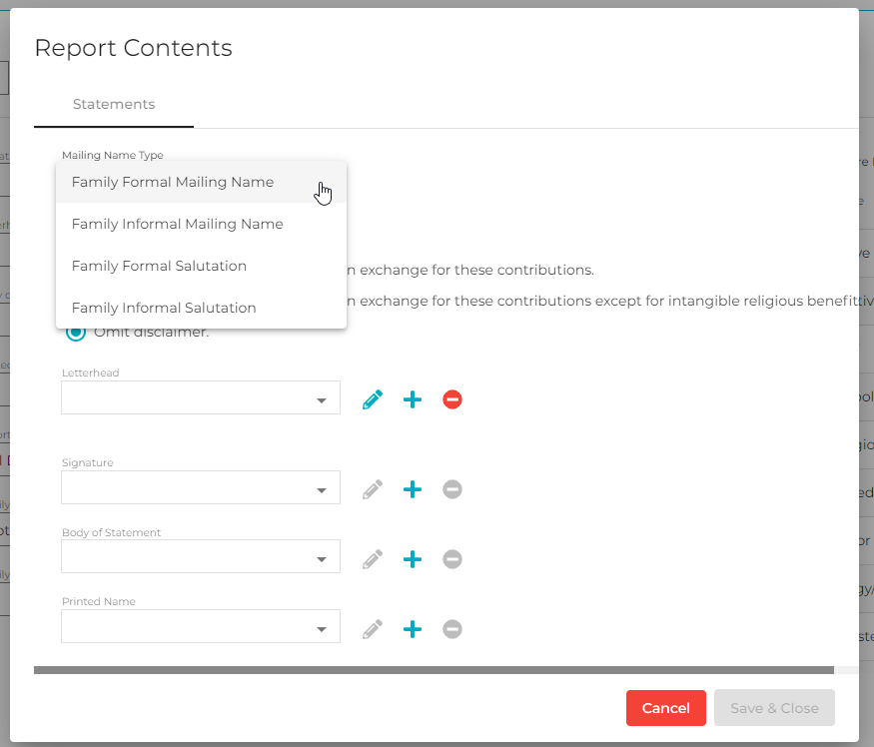
  - You can select one of the Radio buttons for the “IRS Disclaimer” the first two options will be printed on your statements with the text shown and the 3rd option will omit the disclaimer. *The IRS does recommend a detailed contribution statement be sent and on the statement you should have some sort of language that indicates that no goods or services were provided by the organization.

  - Next is the Letterhead option. For this process select “Use Organization’s Name and address” from the drop down list.
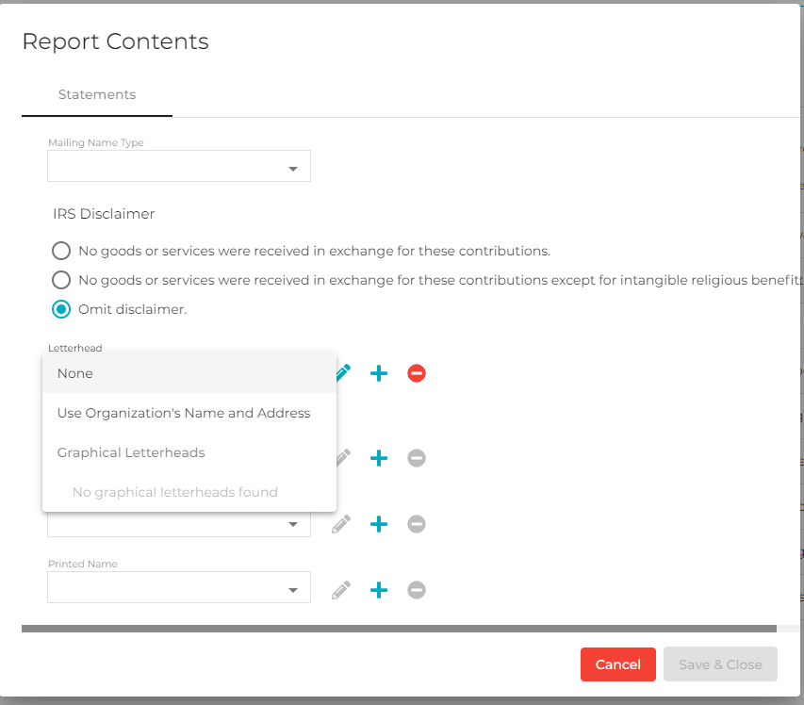
  - Next option is the signature this takes some setup but takes a little more technical knowledge than this article is made for. It is possible to add the priests signature if they desire without signing every statement.
  - Body of statement dropdown is the next option. You can see below the dropdown the preview of the option you have selected. To change the current selection click the pencil icon. To add a new statement click the plus sign icon.

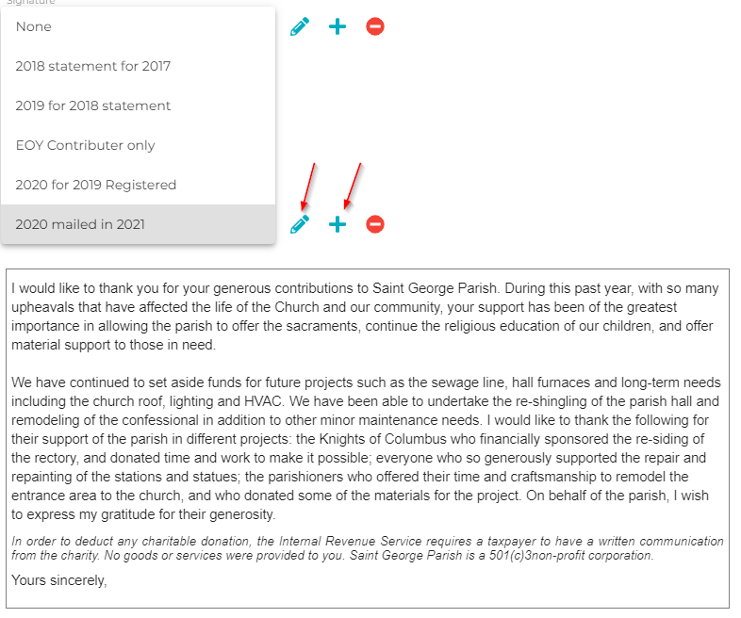
- On the main screen.
  - Below you can select whether to run for all parishioners (All Families). Only specific parishioners by selecting a list (Only Selected Families) or by Family DUID (Family ID).
  - Make sure your dates are set to the range you would like to run the reports for, (for example 1/1/2021-12/31/2021). The bottom checkbox is for printing labels if you are not using window envelopes.
  - These settings are set by clicking on the gear in the upper right hand corner and clicking the contents option and explained in step 6.
  - You can leave these as shown. This will run All details for registered and unregistered families and all Family WorkGroups.
  - You will want to select all Funds and All Family Groups for these reports by clicking on the checkbox at the top of each list.

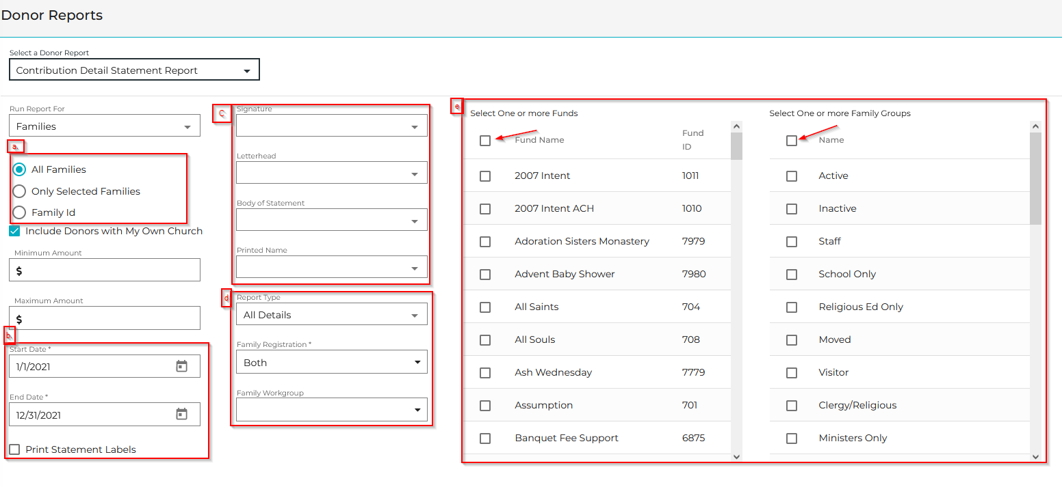
- At this point you should be able to click the export statements button in the upper right hand corner. If you had checked the box in step 7b this will also download the labels file. You should be able to open this PDF and print and mail them out to your parishoners.
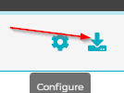

NOTE: For more detailed information and other support articles for End of Year in ParishSOFT browse to the following.

https://support.parishsoft.com/hc/en-us/sections/4415881077773-New-Offering-End-of-Year-DMO-

