Process for Managing Deceased Parishioners
- Login to https://siouxfalls.parishsoftfamilysuite.com/ with your username and password.
- Once logged in click on the Family Directory tab.
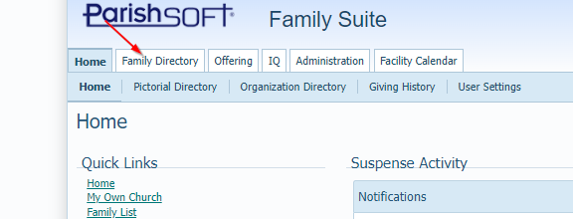

- Use the search bar to find the parishioner’s family record you are trying to locate and open the record.

- Click on the Member Details tab.
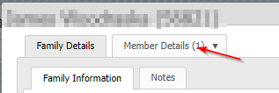

- Click the button at the bottom of the screen
  - Change the “Status” dropdown to deceased
  - Enter in the “Date of Death” box the date of their death.
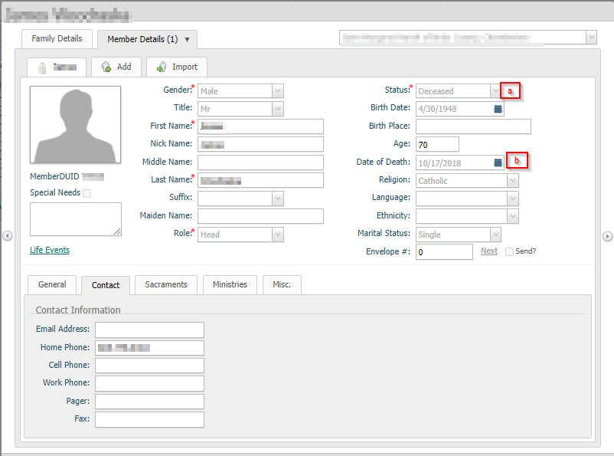
- Click the button at the bottom of the screen.
- If there are other members of the family go back to the family details screen and update the “First Name(s)”, “Formal Mailing Name:”, “Informal Name”, “Formal Salutation”, and “Informal Salutation” accordingly by clicking the button making the changes and then clicking on the button.
- If this is the last member of the family click the button and change the “Family Group” to “Deceased” and Uncheck the box next to “Registration Status” and make sure to click the button once finished with your changes.

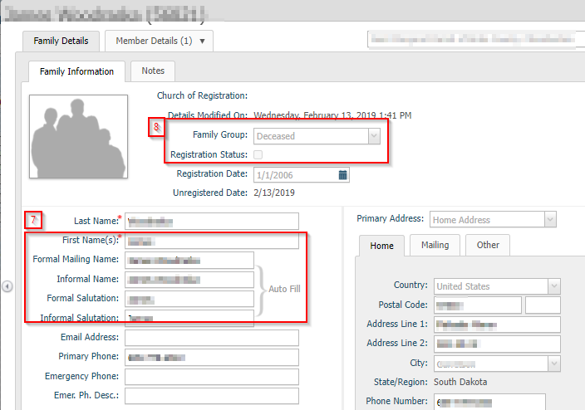

- If possible please fill out the sacrament information for the funeral. Even though a funeral is not a sacrament this is held under the Sacraments menu in ParishSOFT.
- Go to Sacraments -> Add/Edit Sacrament
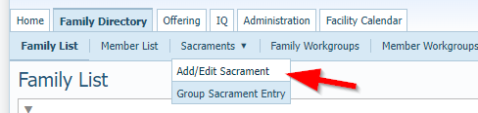

- Select Funeral from the sacrament dropdown and enter the last name and click the Search button
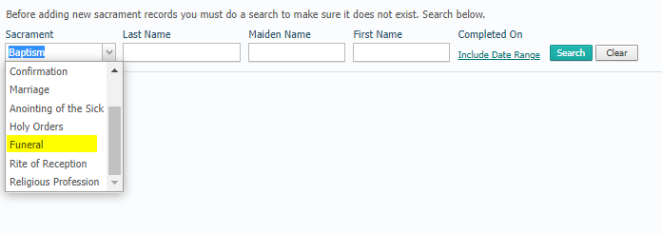
- Click the “Create new Funeral Record”.
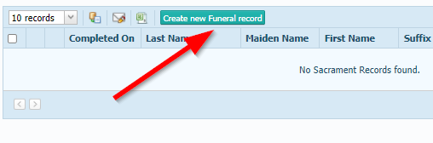
- This will bring you to the member search Screen where you will search for and select the parishioner whose information you are filling in. NOTE: If you have set them as deceased already in the Family Directory of ParishSOFT you can use this as part of the member search filter.
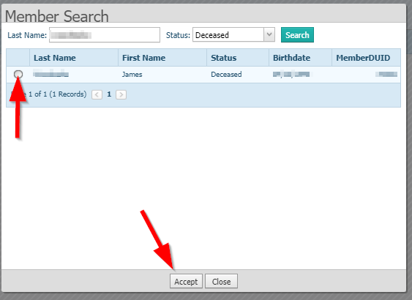

- The next screen will have you fill in the funeral information along with Date of Death. If you can fill out the top section and Date of Death that would be helpful.
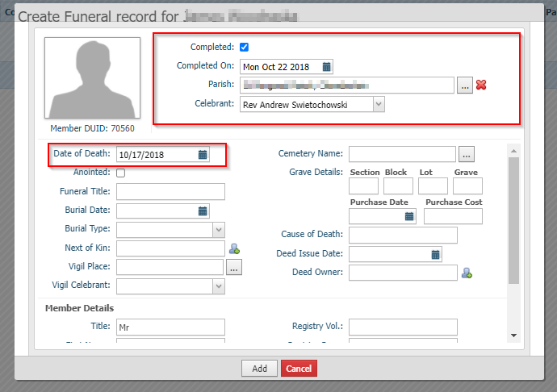

- When filling out Parish Click the 3 dots next to the text box and do a search for the parish. Using postal code is easiest and if you cannot find the parish under the city postal code and it is a mission church use the Main parish in the cluster’s parish postal code. Select the Radio button next to the parish you wish to select and click the accept button at the bottom.
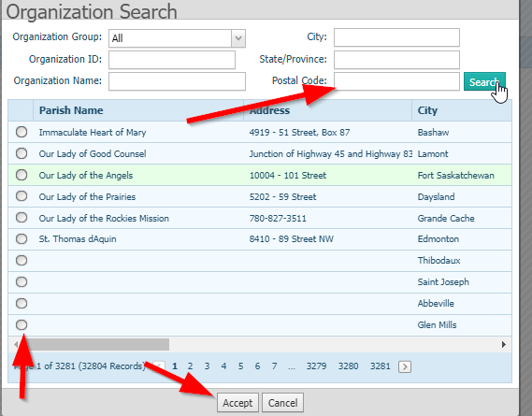
- When searching for the celebrant Type in “Rev Formal first name formal last name” for example “Rev Thomas Hartman” not “Rev Tom Hartman”.
- Once you have all the information filled out click the Add button at the bottom of the screen.

