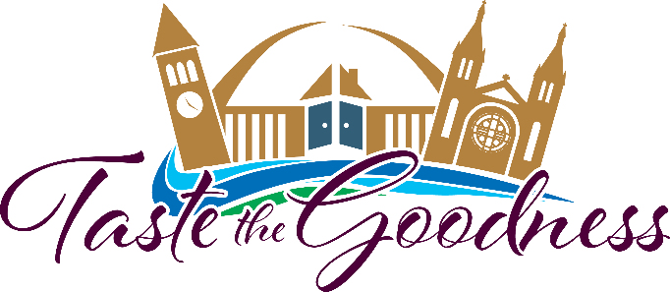
Join us on August 5th from 5:00-9:00 PM for the 2023 Taste the Goodness event benefiting the Bishop Dudley Hospitality House.
Held outdoors in downtown Sioux Falls, attendees can plan on a great evening of fun and fellowship while tasting a wide array of foods, craft beers, wines, and other beverages. Music will be provided, along with an outstanding silent auction, exciting games and activities.

In 2023, BDHH was approached with an unexpected and impactful opportunity to join focus with another non-profit to expand their Family Services program. They will be moving their family units from their downtown location to 409 N Western Ave in Sioux Falls, SD allowing them to expand the number of families they can provide safe housing for as well as more community resources to give them a helping hand.

For on-going event updates or to purchase your ticket to Taste the Goodness, visit our website www.ccfesd.org or call 605-988-3765. Now more than ever, the mission of the Dudley House needs our support.

