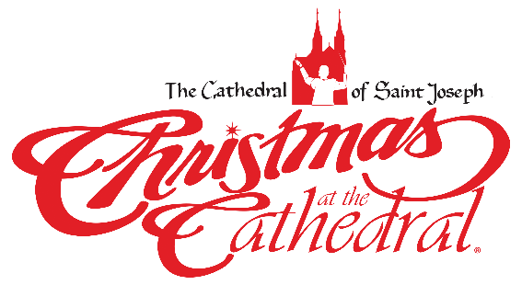CHRISTMAS AT THE CATHEDRAL

The 27th annual Christmas at The Cathedral will be performed with six concerts, December 14-17, 2023 at the Cathedral of St Joseph. This year’s theme, “The Heavens Declare,” is a first-hand account of the monumental events surrounding Jesus’ birth and His miraculous mission and impact through the experience of one of the magi.

This inspiring production features actor, Mark Christopher Lawrence, best known for his role as Big Mike on the NBC series Chuck. He has also made guest appearances on many television programs and movies. The script will come alive through the inspiring musical compositions and arrangements of Christmas at The Cathedral Music Director and Conductor, Dan Goeller; and our featured soloists, Nashville recording artists, Shelley Jennings and Carlos Santiago; along with the Christmas at The Cathedral Orchestra and Choir. In addition to being an inspiring Christmas experience, Christmas at The Cathedral supports the poor and vulnerable in our midst through endowments for the Bishop Dudley Hospitality House, as well as the ongoing care of the Cathedral of St Joseph, one of the region’s most significant civic and sacred landmarks. Christmas is not just an historical event or celebration, it is something that happens within each of us every moment of every day. We look forward to sharing with you the hope and joy of God’s Incarnation during the 27th annual Christmas at The Cathedral, The Heavens Declare!

Tickets will be available soon! To see sponsorship opportunities contact the Catholic Community Foundation at 605-988-3765. Or visit our website www.ccfesd.org

