The 28th Annual “BISHOP’S CHARITY FISHING TOURNAMENTS”

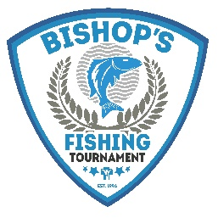

Now more than ever, we need to support Seminarian Education.
Last chance to register for the 28th Annual “Bishop’s Charity Fishing Tournaments” on June 5th in Bigstone and June 12th in Pierre.
Whether you enjoy fishing or just want to show your support for seminarian education you can get involved!
1. Call our office or scan below to register your team or make a donation today!
2. Join us for a social hour and prime rib dinner celebrated by Bishop DeGrood after the tournament(s).
3. Say a prayer for our current seminarians and commit to praying the vocations prayer for increased vocations in our diocese.

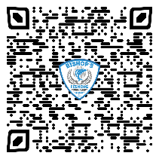

To purchase your tickets, call us at 605-988-3765 or visit ccfesd.org or scan below.

