Bulletin Announcements
For immediate release as space allows:

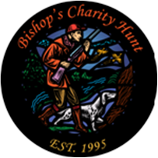
BISHOP’S CHARITY HUNT

The 28th Annual “Bishop’s Charity Hunt” is scheduled for Monday and Tuesday, September 19 & 20 at Horseshoe “K” Ranch near Kimball, SD. This is a truly memorable outing that includes lodging, breakfast, lunch, dinner, social, trap shoot, hunting, and pheasant cleaning. An additional bonus is fellowship with Bishop Donald DeGrood, daily Mass and interaction with many priests from our diocese. All proceeds from this event benefits the Newman Catholic Campus Ministry in our diocese.

The “Bishop’s Charity Hunt” has grown into a friends and family tradition for many. Whether you bring your friends, your parents or your son/daughters, it’s an opportunity to share fellowship, faith and have fun making lasting memories, while raising money for an amazing cause.

For more information or to register please contact the Catholic Community Foundation at
605-988-3765 or visit www.ccfesd.org.

