Parish Bulletin Announcement for placement as space allows:

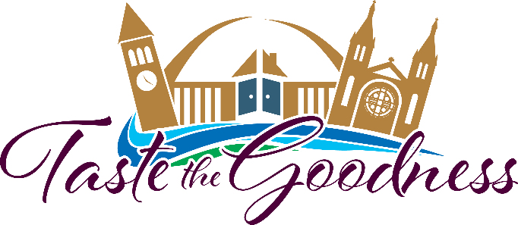
SAVE THE DATE - The Catholic Community Foundation is excited to announce that the “Taste the Goodness” event, benefitting the Bishop Dudley Hospitality House, will take place on Saturday evening, August 6, 2022 from 5:00 to 9:00 p.m. outdoors in downtown Sioux Falls.
Come with your friends to enjoy tastings of a wide variety of foods, craft beers, wine, bourbon and much more. Music and fun will be provided along with a great mobile bidding silent auction!

For on-going event updates or to purchase your ticket to Taste the Goodness, visit our website www.ccfesd.org or call 605-988-3765. Now more than ever, the mission of the Dudley House needs our support.

Purchase your tickets and plan now to attend the 2022 Taste the Goodness event scheduled for Saturday, August 6 from 5:00 – 9:00 p.m. Held outdoors in downtown Sioux Falls, attendees can plan on a great evening of fun and fellowship while tasting a wide array of foods, 80 craft beers, wines, and other beverages. Music will be provided, along with a great mobile bidding silent auction, exciting games and activities. This is a come and go event, so if you are unable to attend the entire evening, you are encouraged to join us when you can.

Did you know that in 2021 the Bishop Dudley Hospitality House provided services to 1,749 different individuals, 44 families, including 101 children, served 30,506 lunches and provided 18,742 showers? All these individuals were provided meals, housing, programs, and above all – LOVE!

For on-going event updates or to purchase your ticket to Taste the Goodness, visit our website www.ccfesd.org or call 605-988-3765. Now more than ever, the mission of the Dudley House needs our support.
Matthew 25:40 “The King will reply, ‘Truly I tell you, whatever you did for one of the least of these brothers and sisters of mine, you did for me.’

Taste the Goodness will be here before you know it! Each year we look for over 200 volunteers to help make this even a success for the benefit of the Bishop Dudley Hospitality House! There are MANY opportunities available to help at this year’s event including food servers, beer and wine pourers, sanitation monitors, auction runners, and help with set up and tear down. Taste the Goodness will be held on Saturday August 6 from 5-9 PM this year.

You can find all the volunteer information on our website: https://ccfesd.org/events/taste-the-goodness/ or call Krista at 605-988-3769. Now more than ever, the mission of the Dudley House needs our support.

Matthew 25:40 “The King will reply, ‘Truly I tell you, whatever you did for one of the least of these brothers and sisters of mine, you did for me.’

