Bulletin Announcement
For Immediate release as space allows:
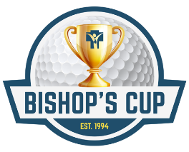

Register today for the
“Bishop’s Cup”

Benefiting Broom Tree Retreat & Conference Center

The 2022 Bishop’s Cup golf tournament will be held on Monday, August 22nd at two of Sioux Falls’ premier golf courses; Minnehaha Country Club and The Country Club of Sioux Falls. All proceeds from this charity event supports Broom Tree Retreat and Conference Center.

Golfers will have three opportunities this year to support Broom Tree!
- The Morning Round: 7:30 AM shotgun start, played only on TCCSF, reserved for individual teams and sponsors who prefer the morning round.
- The Afternoon Round: 12:30 PM shotgun start, reserved for Birdie and above sponsors, played on both MCC and TCCSF
- The 9-Hole Fun Event: 2:00 PM shotgun start, played on the par 3 executive course at TCCSF

Additionally, there is a great opportunity for non-golfers to support Broom Tree Retreat and Conference Center through the purchase of hole signs that will be placed on the courses to promote your business, family or any intention.

Your support will ensure Broom Tree is available to people of all ages and income levels for years to come! For more information or to register visit ccfesd.org or contact the Catholic Community Foundation at 605-988-3765.

