For Release in the November 13 & 14 Parish Bulletins

(Use logo if desired)

Start a new family tradition! The 25th Annual Christmas at the Cathedral – Dec. 16, 17, 18, 19

For many, the Holidays are filled with traditions. Why not consider staring a new family tradition, as you prepare for the coming of Jesus by attending an inspiring performance at Christmas at the Cathedral. The 25th Christmas at the Cathedral will be performed with six concerts December 16-19 at the Cathedral of St. Joseph. This year’s theme, “Be Born in Me” is a first-hand account of God’s Incarnation into the human race. Audiences will experience Mary’s perspective, through actress Apalonia Davalos, on the monumental moments of Jesus’ birth, and his miraculous life and mission on earth. The meaning of Christmas will come alive through inspiring musical compositions and arrangements of Music Director and Conductor Dan Goeller, and our featured soloists Nashville recording artists, Shane O’Connell and Shelley Jennings, along with the Christmas at the Cathedral Orchestra and Choir.

Proceeds from this year’s performances will benefit the Bishop Dudley Hospitality House and the Cathedral of St. Joseph ongoing care and maintenance endowments.

For more information and performance times visit www.ccfesd.org. There are several ways to purchase your tickets: 1) on-line at www.ccfesd.org, 2) phone 605.988.3765 3) email events@ccfesd.org, 5) stop by the Catholic Community Foundation Office (523 N Duluth Ave) 6) general admission tickets are also available for purchase at all the Sioux Falls HyVee Stores.

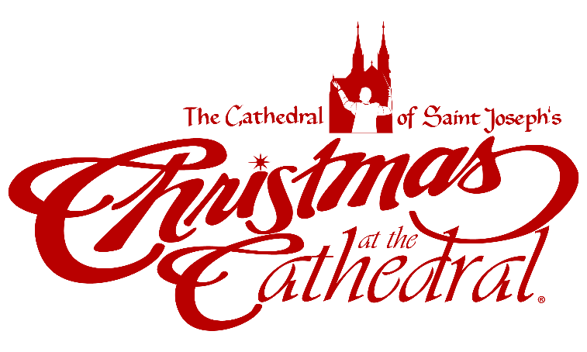
For Release in the November 20 & 21 - and November 27 & 28 Parish Bulletins

(Please use the Christmas at the Cathedral logo as space allows.)

Searching for the True Meaning of Christmas?

As the rush of Holidays approach, allow yourself some time to slow down this advent season and reflect on the true meaning of Christmas. Plan now to take a spiritually relaxing break, in the beautiful environment of the Cathedral of St. Joseph, as you surround yourself with the magnificent sights and sounds of Christmas at the Cathedral. Experience God’s Incarnation into the human race through actress Apalonia Davalos, as she shares Mary’s perspective on the monumental moments of Jesus’ birth and his miraculous life and mission on earth. You’ll feel the meaning of Christmas come alive with inspiring musical compositions and arrangements by Music Director and Conductor, Dan Goeller, and our featured soloists Nashville recording artists, Shane O’Connell and Shelley Jennings, along with the Christmas at the Cathedral Orchestra and Choir.

Proceeds from this year’s performances will benefit the Bishop Dudley Hospitality House and the Cathedral of St. Joseph ongoing care and maintenance endowments.
For more information and performance times, visit www.ccfesd.org. There are several ways to purchase your tickets: 1) on-line at www.ccfesd.org, 2) phone 605.988.3765 3) email events@ccfesd.org, 5) stop by the Catholic Community Foundation Office (523 N Duluth Ave) 6) general admission tickets are also available for purchase at all the Sioux Falls HyVee Stores.

For Release in the December 4 & 5 and December 11 & 12 Parish Bulletins

(Please use the Christmas at the Cathedral logo as space allows.)

25th Annual Christmas at the Cathedral – Dec. 16, 17, 18, 19

Time is drawing near for the 25th Annual Christmas at the Cathedral. This year’s theme, “Be Born in Me” is a first-hand account of God’s Incarnation into the human race. Audiences will experience Mary’s perspective, through actress Apalonia Davalos, on the monumental moments of Jesus’ birth, and his miraculous life and mission on earth.
In addition to bringing the community together to celebrate this special time of year, Christmas at the Cathedral supports the poor and vulnerable in our midst through the Bishop Dudley Hospitality House Endowment as well as the ongoing care of the Cathedral of St. Joseph, one of the region’s most significant civic and sacred landmarks. We look forward to sharing the joy of Advent and the Christmas season with you during the 25th Annual Christmas at the Cathedral.

Visit www.ccfesd.org for more information and performance times. Tickets are selling fast – get yours today at any of the following outlets: 1) on-line at www.ccfesd.org, 2) phone 605.988.3765 3) email events@ccfesd.org, 5) general admission tickets are also available for purchase at all the Sioux Falls HyVee Stores.

