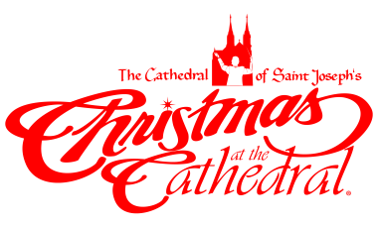
PARISH BULLETIN ANNOUNCEMENTS
Feel free to cut and paste what will fit in your available bulletin space.

For Release in the October Parish Bulletins beginning October 16 & 17, 2021

25th Annual Christmas at the Cathedral – Dec. 16, 17, 18, 19

The 25th Christmas at the Cathedral will be performed with six concerts December 16-19 at the Cathedral of St. Joseph. This year’s theme, “Be Born in Me” is a first-hand account of God’s Incarnation into the human race. Through actress Apolonia Davalos, audiences will experience Mary’s perspective on the monumental moments of Jesus’ birth, and his miraculous life and mission on earth.

From the Annunciation to the Resurrection, the meaning of Christmas will come alive through the inspiring musical compositions and arrangements of Music Director and Conductor, Dan Goeller, and our featured soloists, Nashville recording artists, Shane O’Connell and Shelley Jennings, along with the Christmas at the Cathedral Orchestra and Choir.

In addition to bringing the community together to celebrate this special time of year, all proceeds from Christmas at the Cathedral will support the poor and vulnerable in our midst served at the Bishop Dudley Hospitality House, as well as the ongoing care of the Cathedral of St. Joseph, one of the region’s most significant civic and sacred landmarks. We look forward to sharing the joy of Advent and the Christmas season with you during the 25th annual Christmas at the Cathedral.

There are several ways to purchase your tickets: 1) on-line at www.ccfesd.org, 2) phone 605.988.3765 3) email events@ccfesd.org, 5) stop by the Catholic Community Foundation Office (523 N Duluth Ave).

Please also note that many volunteers are needed and if interested, you are encouraged to call 605-988-3769 for details.

