Parish Bulletin, Email, and Electronic Display Announcements
For immediate release

A digital version of this announcement will also be uploaded to the Ministry Forum for easy copy and pasting. http://www.sfcatholic.org/ministry-forum/

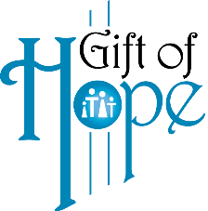

Catholic Family Services 21st Annual Gift of Hope event
“Lighting the Path to Hope and Healing” – A Candlelight Celebration
Saturday, April 10th – 8:00 PM
“I have come to the world as its light, to keep anyone who believes in me from remaining in the dark”, John 12:46
As a fundraiser for Catholic Family Services, this year’s Gift of Hope event will light the path to hope and healing for us all. A beautiful, outdoor candlelight celebration will take place on Saturday April 10th at 8 PM on the steps of the Cathedral of St. Joseph to join in unity and heal the wounds of our past while lighting the path of hope for our future. Inspirational messages will be given from Bishop Donald DeGrood and CFS Executive Director Emily Leedom along with praise and worship music with Jon Konz. A moment of remembrance will take place to honor long-time CFS Director, Dr Marcie Moran, who passed away January 21st.
You can pre-purchase your Gift of Hope candles and luminaries in remembrance or honor of individuals or any specific prayer intention you may have. At the end of the event, you can take these home with you and light as you pray for your intentions. Proceeds from these sales benefit Catholic Family Services’ Gift of Hope Endowment Fund. In the event of inclement weather, the event will be moved inside the Cathedral. For more information and to order visit ccfesd.org, email us at events@ccfesd.org or call our office at 605-988-3765.

