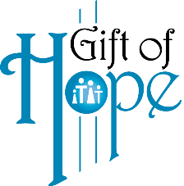
Bulletin Announcements
For release starting February 1 through April 3

Catholic Family Services 21st Annual Gift of Hope event
Lighting the Path to Hope and Healing
Saturday, April 10 – 8:30 p.m.
Cathedral of St. Joseph, Sioux Falls, SD
We invite you to join us for a NEW Gift of Hope Event to benefit Catholic Family Services! A candlelight celebration will be held on Saturday April 10th on the steps of the Cathedral of St. Joseph to unite us all in Lighting the Path to Hope and Healing.
Proceeds made from the sale of our Gift of Hope Commemorative Candles will benefit the Gift of Hope Endowment Fund. Through this fund, CFS is able to provide programs like “Camp Sydney,” a youth grief camp, suicide prevention, health and wellness of the body, mind, and spirit to people of all faith in our communities.
Order your commemorative candle online at ccfesd.org, email us at events@ccfesd.org or call our office at 605-988-3765.

